Hasura permissions generator

Hasura Operations
- select_permissions
- insert_permissions
- update_permissions
- delete_permissions

Design principle
Policies define intent → generator translates into Hasura metadata

RBAC generator
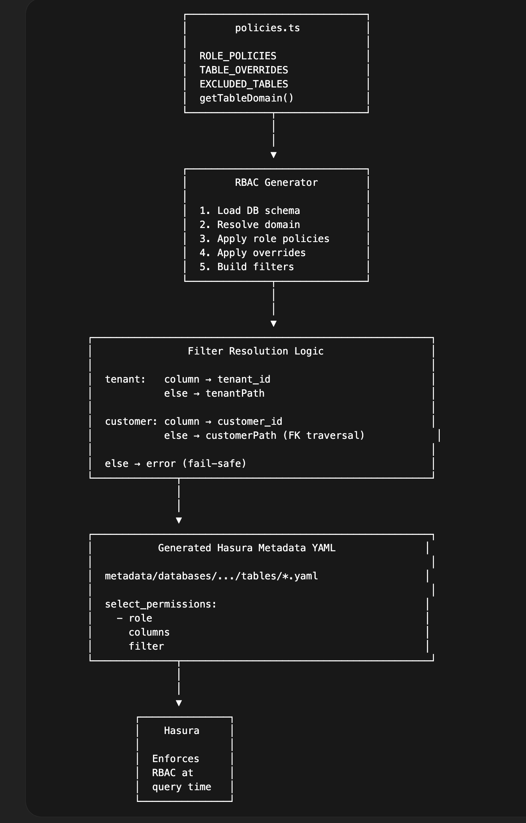

Overview
This RBAC generator automatically creates Hasura table permissions based on:
- Database schema (introspected from Postgres)
- Centralised policy definitions (policies.ts)
- Table-level overrides for exceptions
It ensures:
- Consistent access control across all tables
- Safe multi-tenant and customer isolation
- Minimal manual Hasura metadata edits

Architecture

Inputs
- Database schema
  - Tables, views, materialized views
  - Columns (tenant_id, customer_id, etc.)
- policies.ts
  - ROLE_POLICIES → role-based permissions per domain
  - TABLE_OVERRIDES → exceptions per table
  - EXCLUDED_TABLES / EXCLUDED_SCHEMAS
- Domain mapping
  - getTableDomain(schema, table) assigns each table to a business domain

Processing Flow

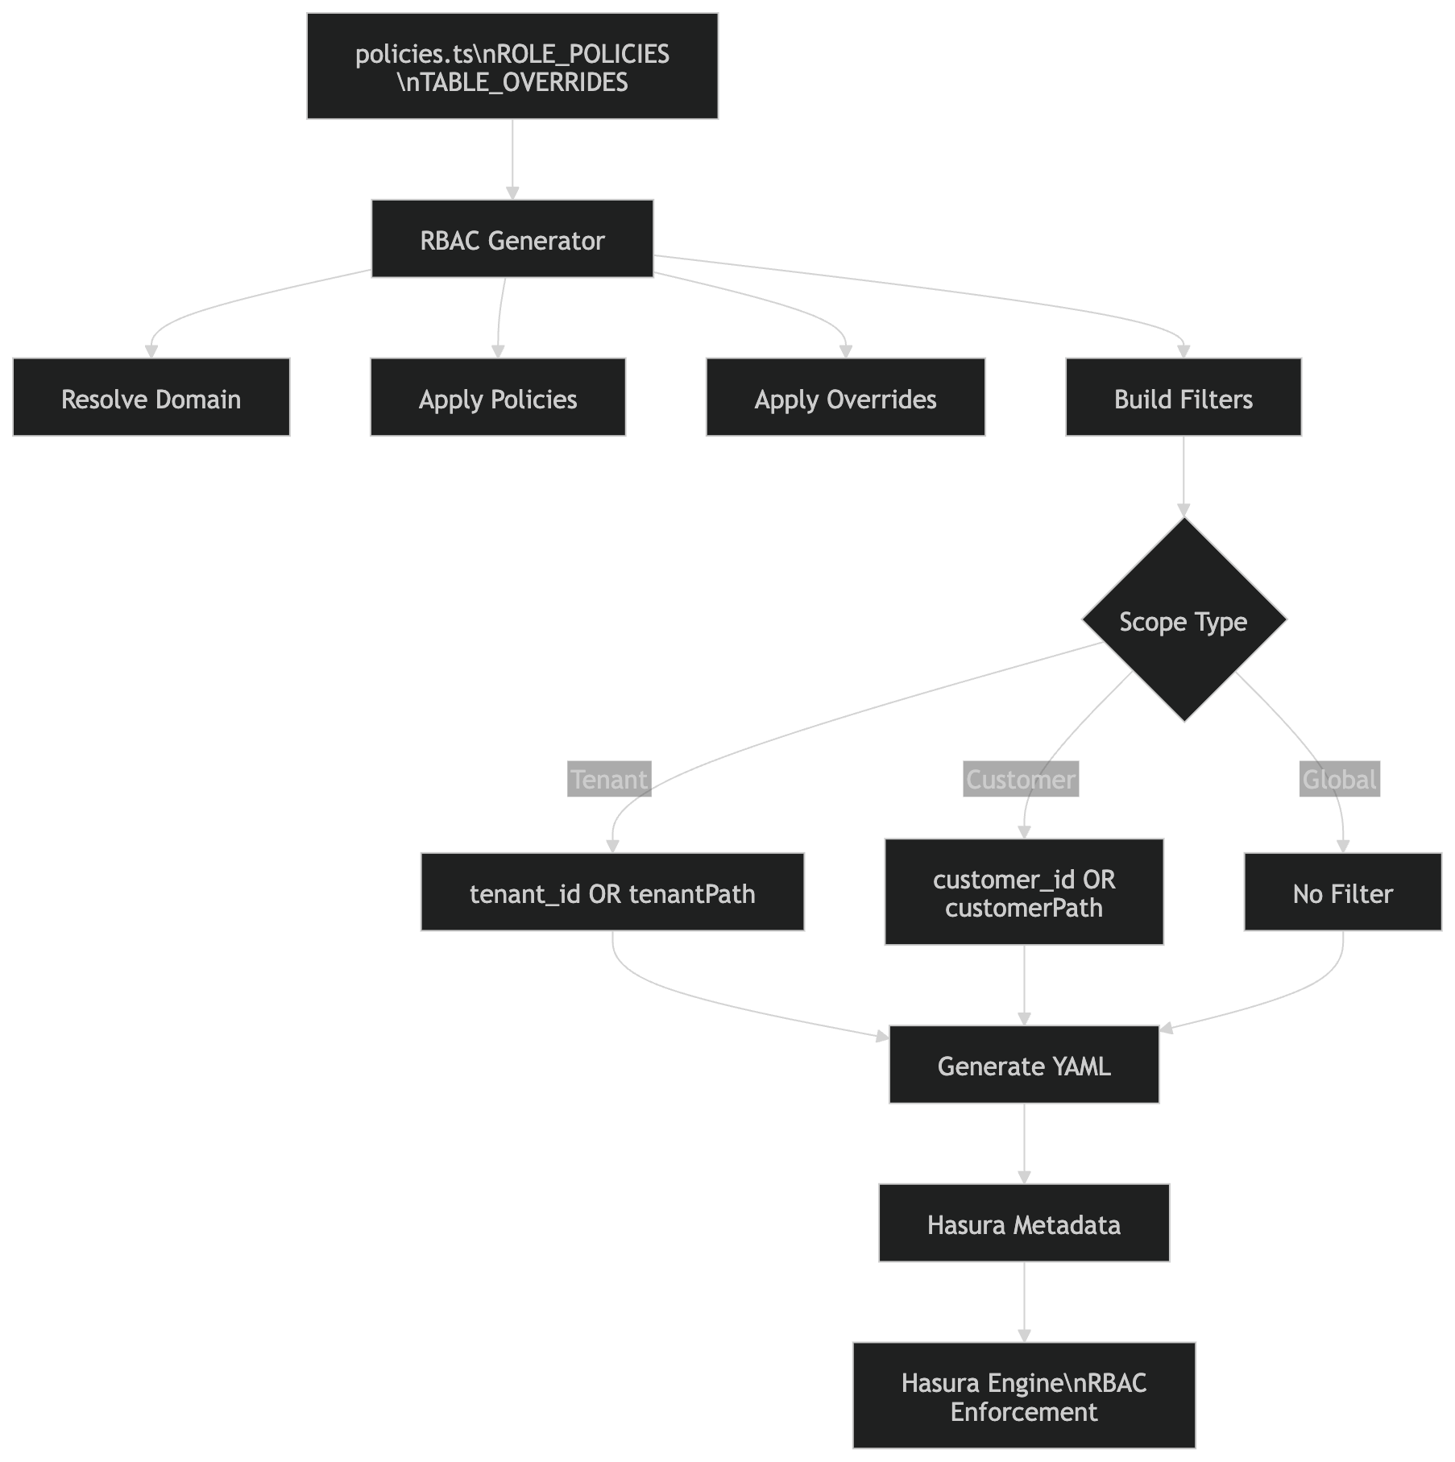
For each table:
- Skip excluded schemas/tables
- Determine business domain
- Load all columns
- Resolve policy for each role
- Apply scope rules:
  - tenant (via tenant_id or path)
  - customer (via customer_id or path)
- Generate Hasura select_permissions
- Write YAML to metadata directory

Output
Generated files:
metadata/databases/<source>/tables/<schema>_<table>.yaml
Each file contains:
table:
schema: ledger
name: journals

select_permissions:
- role: support
permission:
columns: [...]
filter: {...}

Scoping model
Each table falls into one of three access patterns:

1. Tenant-scoped
- Uses tenant_id
- Example:
tenant_id = X-Hasura-Tenant-Id

2. Customer-scoped
- Uses customer_id OR relationship traversal
- Example:
customer_id = X-Hasura-Customer-Id
OR:
journal:
customer_id = X-Hasura-Customer-Id

3. Global (unscoped)
- No filter
filter: {}

Table Overrides
Used for exceptions where default policy cannot be applied.

Example
export const TABLE_OVERRIDES = {
"ledger.journal_lines": {
tenantPath: "journal.tenant_id",
customerPath: "journal.customer_id",
},

"ledger.account_type": {
tenantScoped: false,
customerScoped: false,
},
};

Supported override fields
Field | Purpose
tenantScoped | Enable/disable tenant filter
customerScoped | Enable/disable customer filter
tenantPath | FK traversal for tenant
customerPath | FK traversal for customer

Business Domains
Domains group tables logically and map to role policies.

Example domains
Domain | Schema | Description
ledger | ledger | Financial ledger (journals, accounts)
payments | payments | Payment processing
recon | recon | Reconciliation and reporting
audit | elevate_audit | Audit logs

Domain resolution
Handled via:
getTableDomain(schema, table)

Adding a New Role

Step 1 – Define role in ROLE_POLICIES
export const ROLE_POLICIES = {
analyst: {
ledger: {
columns: "ALL",
tenantScoped: true,
customerScoped: false,
},
},
};

Step 2 – Run generator
make rbac

Step 3 – Apply Hasura metadata
hasura metadata apply

Adding a New Table

Case 1 – Standard table
- Ensure correct schema
- Ensure tenant_id / customer_id if applicable
- Confirm domain mapping
No further action needed.

Case 2 – Table requires traversal (e.g. child table)
Add override:
"ledger.journal_lines": {
customerPath: "journal.customer_id",
}

Case 3 – Global/reference table
"ledger.account_type": {
tenantScoped: false,
customerScoped: false,
}

Exclusions
Defined in:
EXCLUDED_TABLES
EXCLUDED_SCHEMAS
Used to skip:
- migration tables
- system tables
- irrelevant schemas

Safeguards

1. Never allow updates to financial amounts
updateColumns: ["status"] ✅
NOT:
updateColumns: ["amount"] ❌

2. Ledger tables should be mostly immutable
- Journals → ❌ no update
- Journal lines → ❌ no update
- Use reversals, not updates

3. Use UPDATE only for:
- statuses
- metadata
- approvals

Example policies

Support (read-only)
support: {
ledger: {
columns: “ALL”
select: true,
insert: false,
update: false,
delete: false,
tenantScoped: true,
}
}

operations (controlled writes)
operations: {
ledger: {
select: true,
insert: true,
update: true,
delete: false,
columns: "ALL",
insertColumns: ["amount", "currency", "reference"],
updateColumns: ["status"],
}
}

🔐 Admin (full access)
admin: {
ledger: {
select: true,
insert: true,
update: true,
delete: true,
columns: "ALL",
insertColumns: "ALL",
updateColumns: "ALL",
}
}

